UNIVERSITY ADMIT ELIGIBILITY PREDICTOR ASSIGNMENT - 3

|  |  |
| --- | --- |
| Date | 4th October 2022 |
| Team ID | PNT2022TMID54388 |
| Student Name | P.K.Raghul (310619106106) |
| Domain Name | Education |
| Project Name | University Admit Eligibility Predictor |
| Maximum Marks | 2 Marks |

# 1.)IMPORT THE REQUIRED LIBRARIES

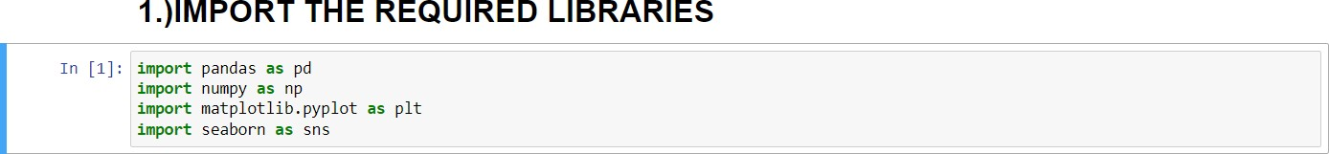

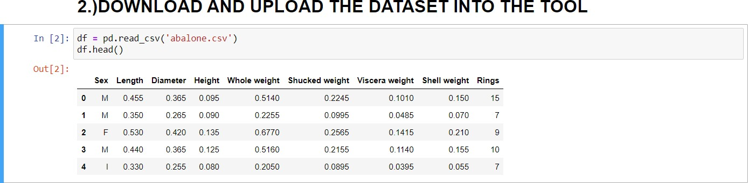**2.)DOWNLOAD AND UPLOAD THE DATASET**

**3.)HANDLE MISSING VALUES AND DEAL WITH THEM**

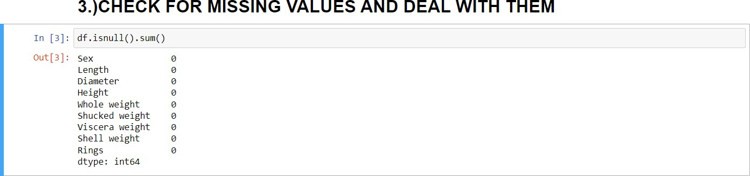

**4.) PERFORM THE DESCRIPTIVE STATISTICS ON THE DATASET**

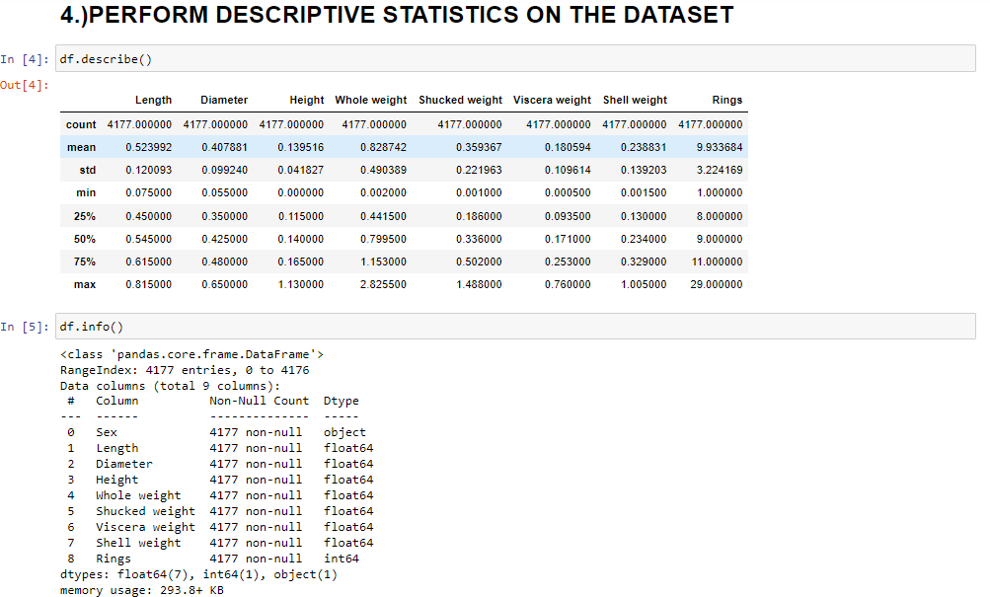

**5.) PERFORM VARIOUS VISUALISATIONS a.) UNIVARIANTE ANALYSIS**

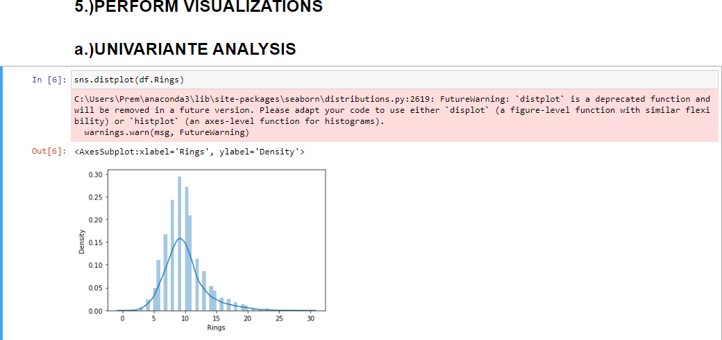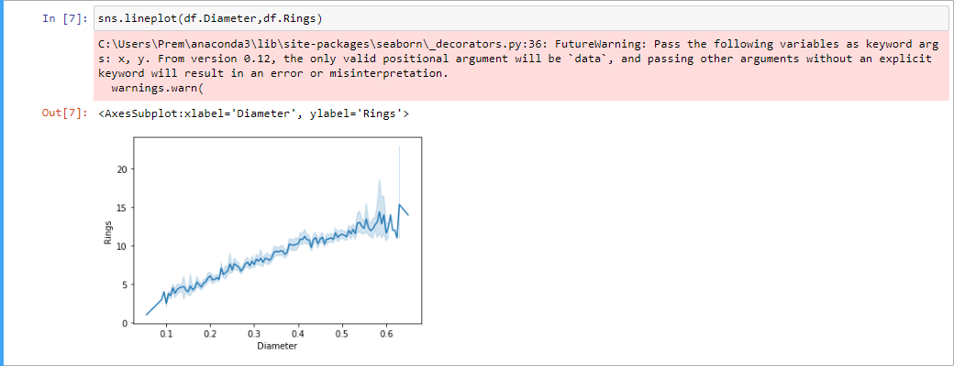

In [8]: plt.pie(df.Sex.value_coumts(),[0.05,0.05,0.05],colors=[’red’,'green', ’blue’],labels=['Male',’Female', ’Infant'],autopct=’%1.1fB%', plt.title('Sex’)

plt.shcm()

In [ 9] : sns . barp1ot (d-fi . Rings . va1ue_count s ) . Index, df .Rings . va1ue_c ount s ( ) )

C : \Us ers \Pren\anaconda3\ lib\site— packages \s eaborn\_deco rato rs. py : 36: F uturef4arn ing: Pass the tolls *ing var tables as Keyword arg

s : x, y . F non ver s ion 0. 1,2

the only val id pos itional argumnt will be’ data,’

and pass irig ot her argunents without an explicit

keynrd will resu lt in an error or nisinterpretation . earnings .earn (

Out[9]: ‹AxesSubplot:ylabel=’Rimgs’›

1 Z J •• 5 6 7 0 9]011lZ1M4b16]7B182DJ]EZ5ZtJ5KTJZ9

# b.) BI - VARIANTE ANALYSIS

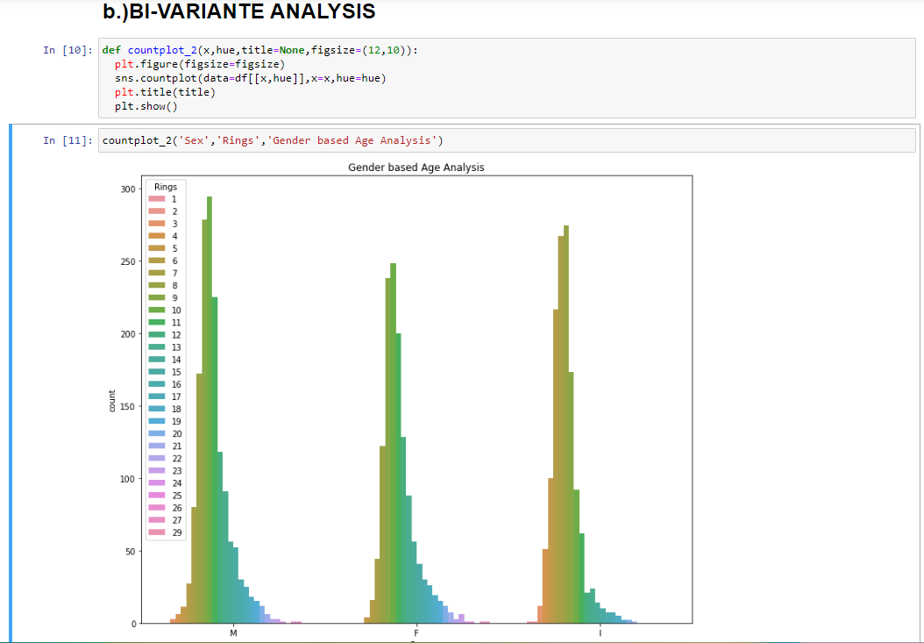

**c.) MULTI - VARIANTE ANALYSIS**

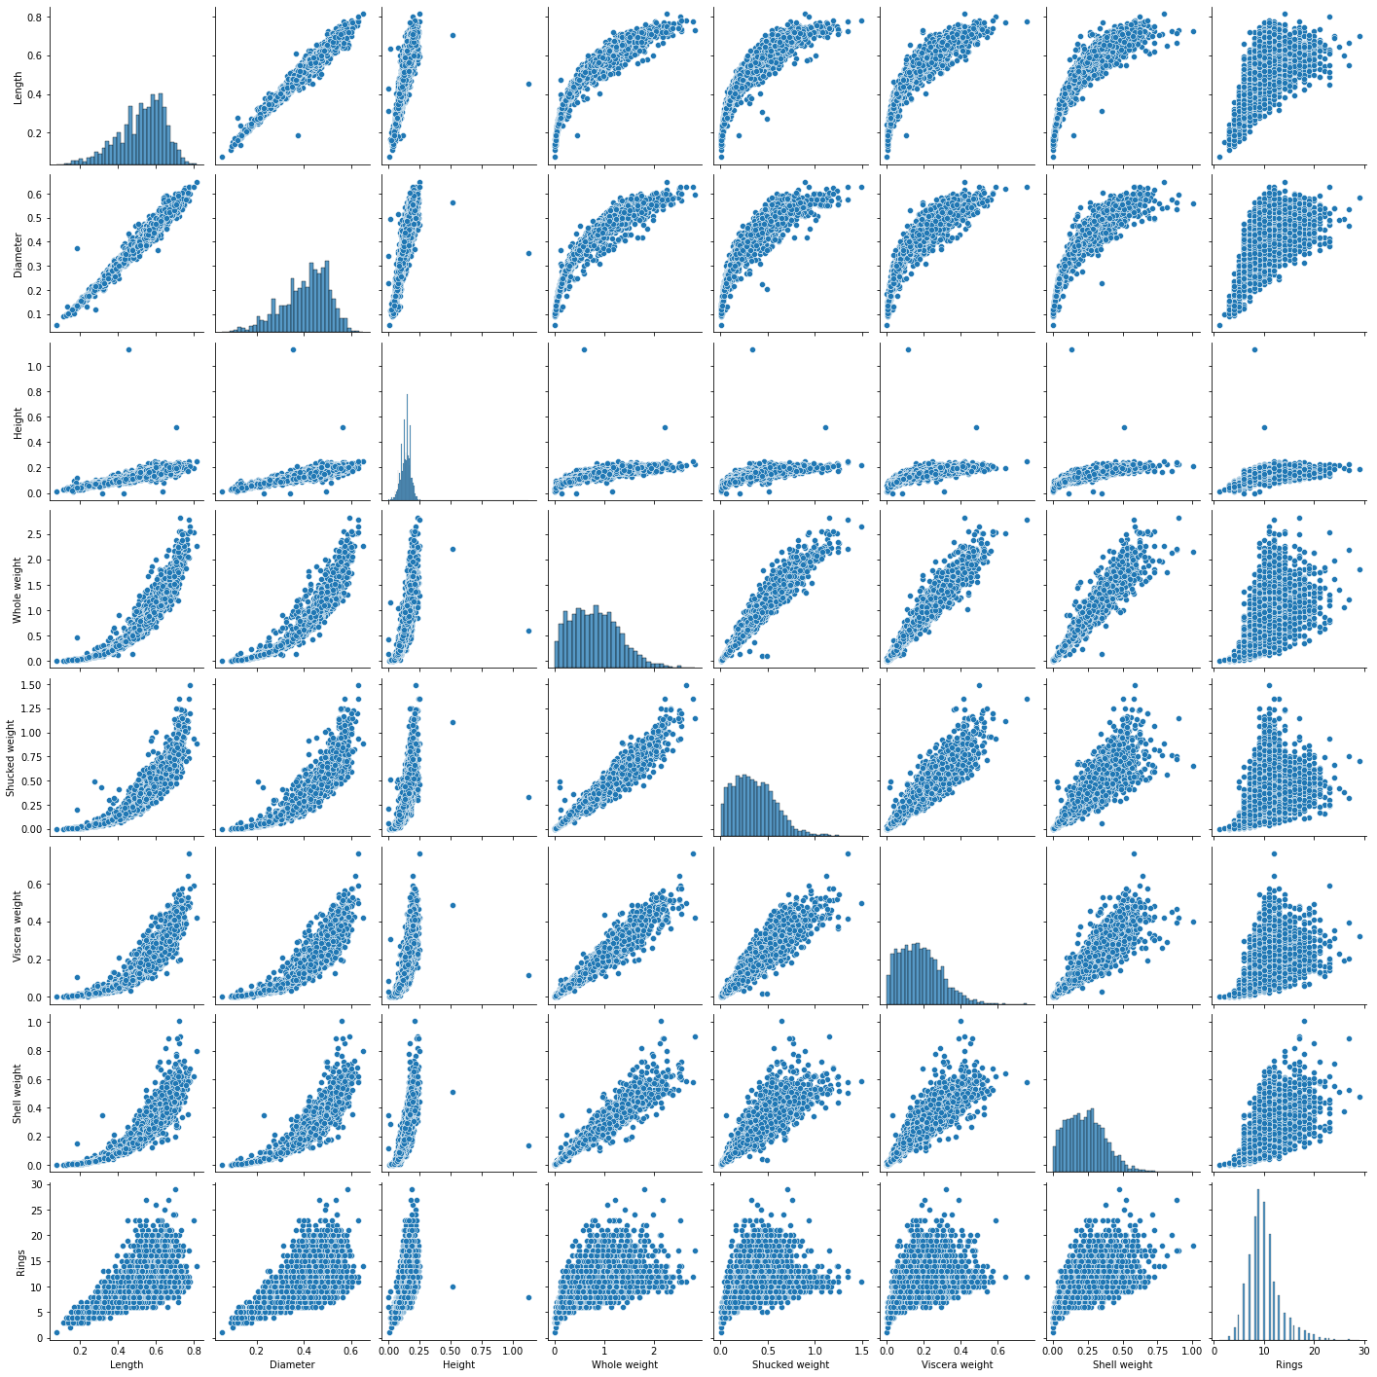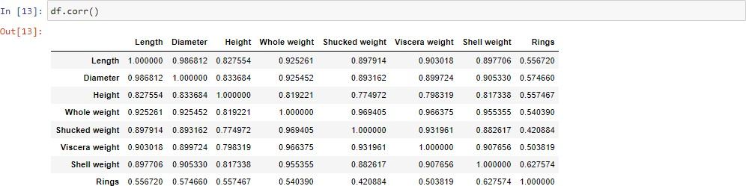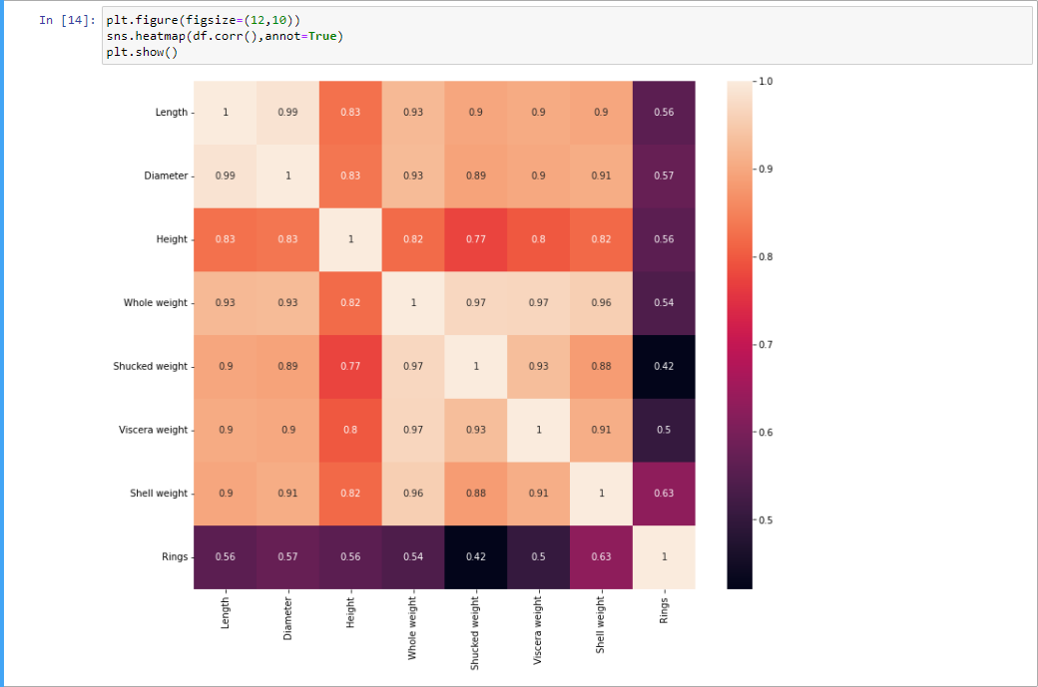

**6.) FIND AND REPLACE THE OUTLIERS**

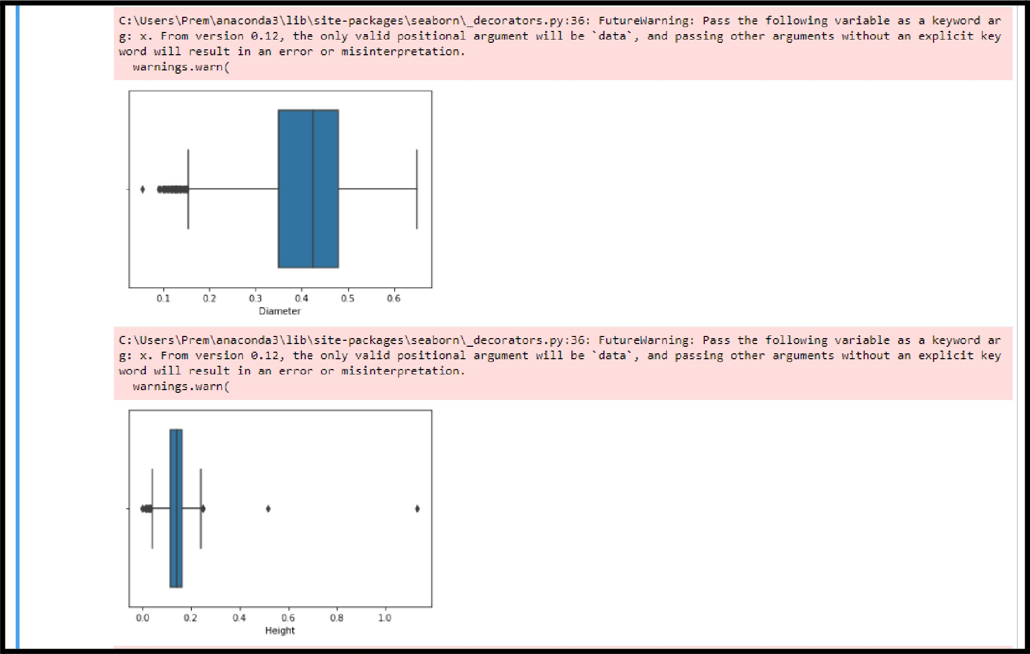

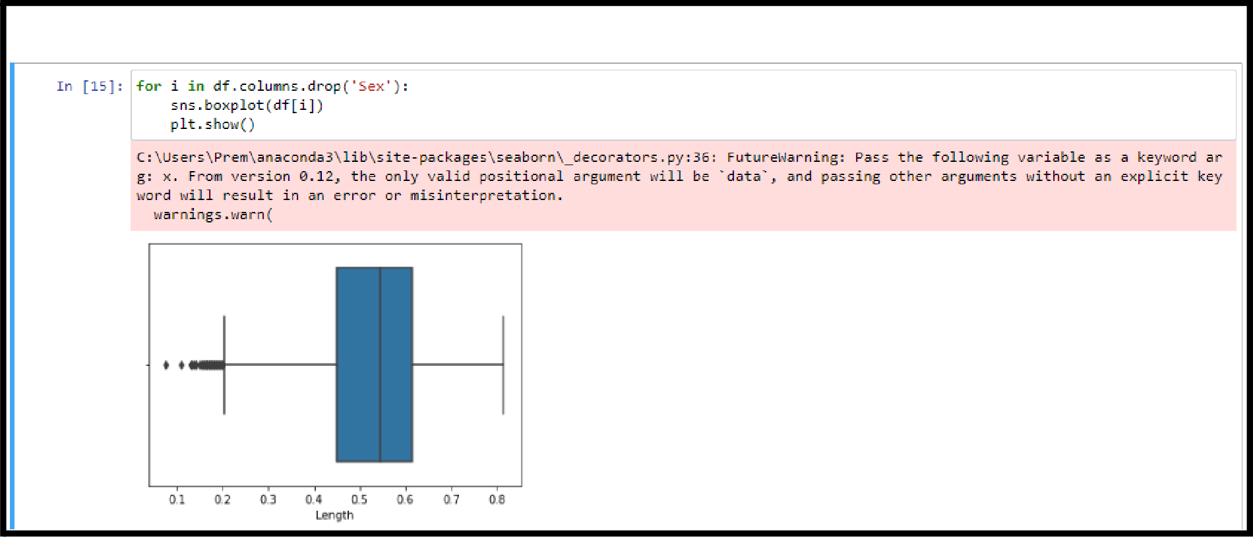

6.)FIND THE OUTLIERS AND REPLACE THE OUTLIERS

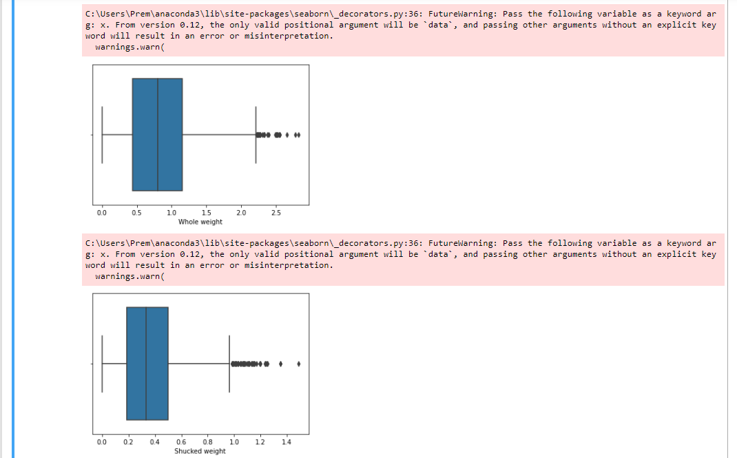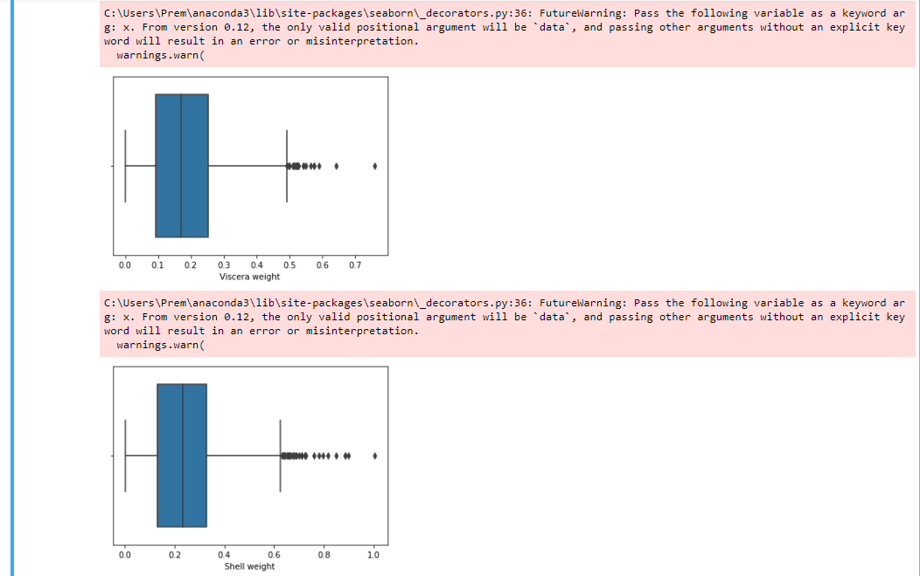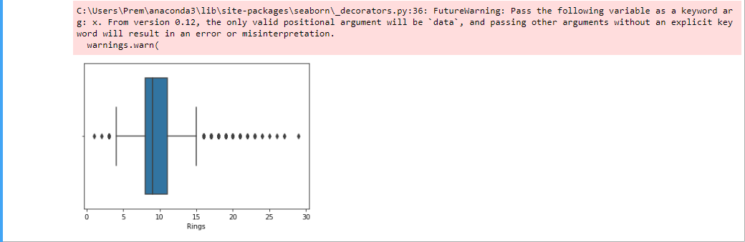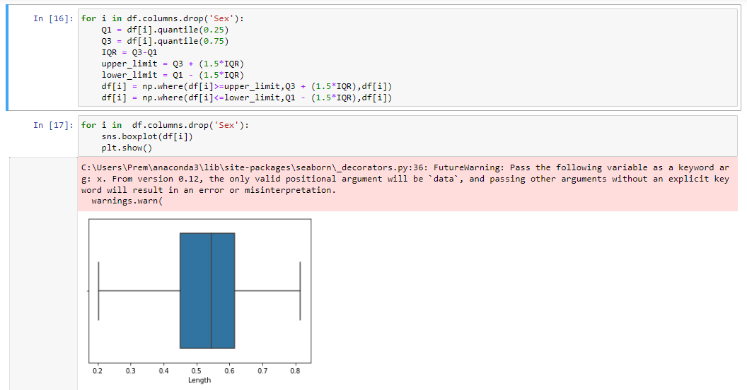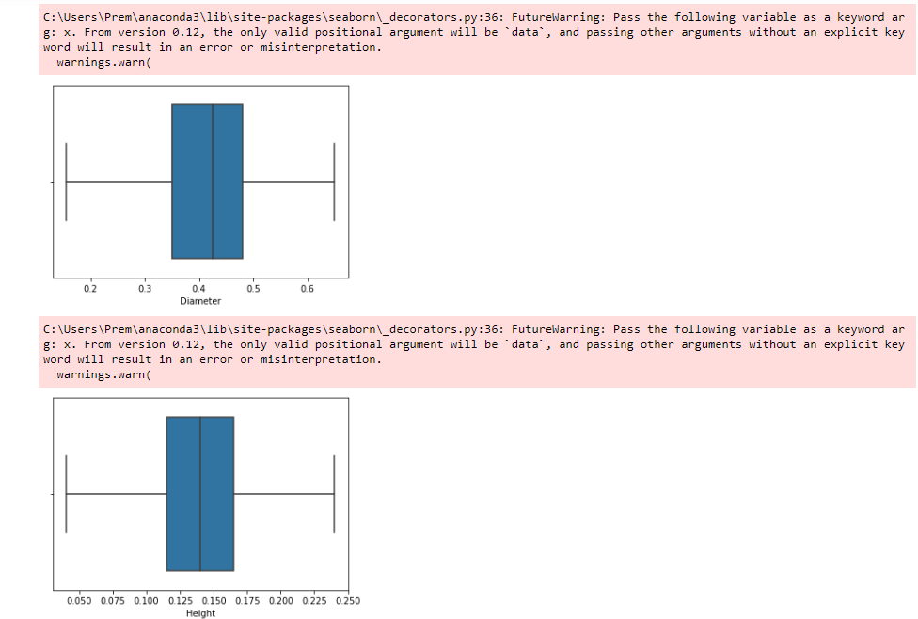

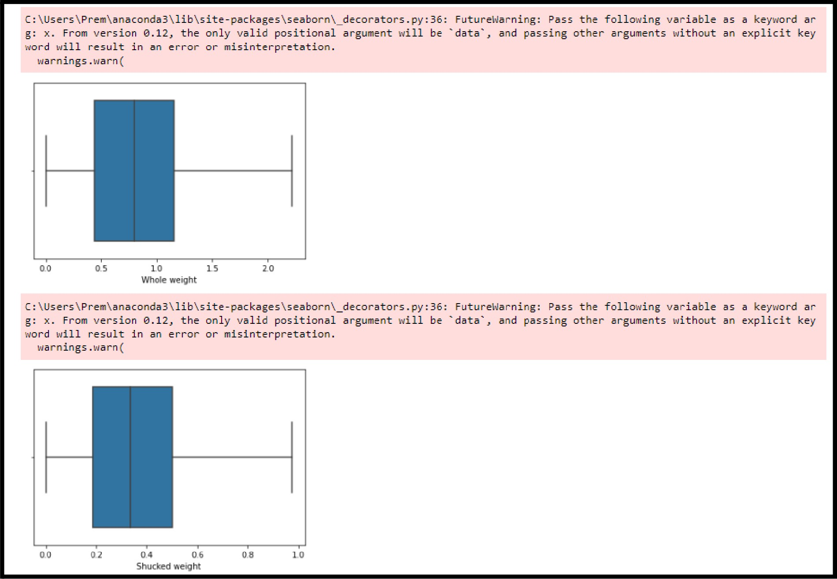

C : \Users\Pren\anaconda3\11b\s1te—packages\seaborn\_decorators.py: 36: Futuretgarn1ng: Pass the fo1Irns1ng var Iab1e as a keywrd ar

g: x. Frrxa vers ton €I.12, the on1y va11d posIt Iona1 argument +s111 be ’ data, ’

word will result in an error or misinterpretation.

ma rnings .ma rn (

e.o or oz or a‹ es

and passIng other argument s ithout an exp1lc It key

C : **\Us ers \Pren\anaconda3 \lib\s ite— pac kage** s **\s eaborn\_deco rato rs** . **py: 36:** F **uturef4arn ing: Pas** s the **tolls *ing var table as a keyemrd ar** g: x. From version B.12, the only valid positional argument will be ’data’, and passing other arguments without an explicit key word will result in an error or misinterpretation.

namings.narn(

e.o e.i o.z e.z e.s es es

# 7.) CHECK FOR CATEGORICAL COLUMNS AND ENCODE THEM

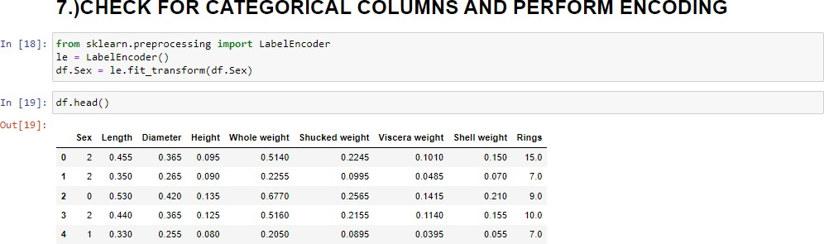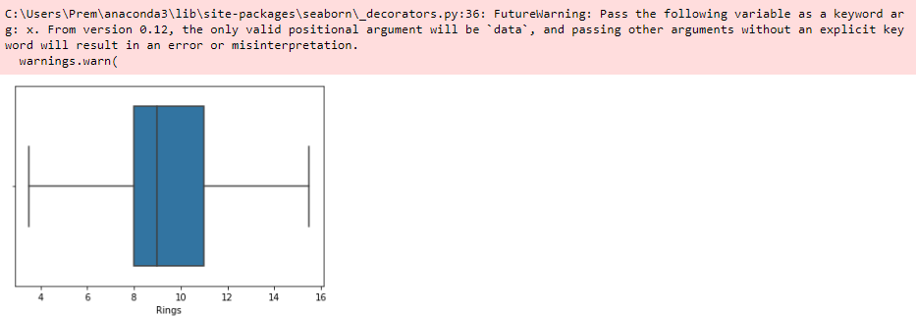

**8.)SPLIT DATA INTO DEPENDENT AND INDEPENDENT VARIABLES**

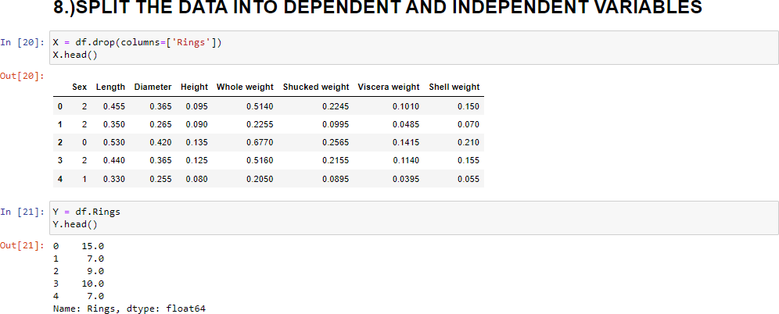

**9.) SCALE THE INDEPENDENT VARIABLES**

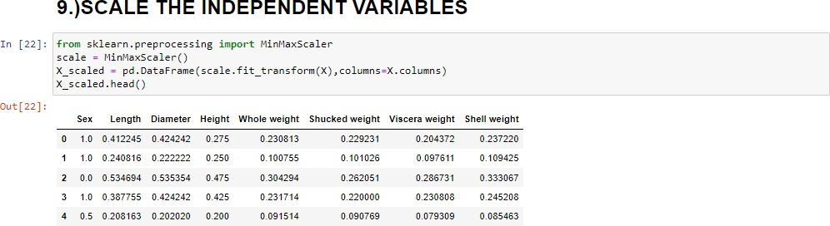

**10.)SPLIT THE DATA INTO TRAINING AND TESTING**

**11.) BUILD THE MODEL**



**12.) TRAIN THE MODEL**



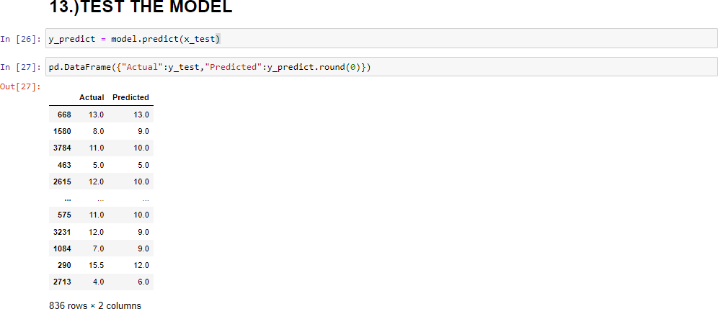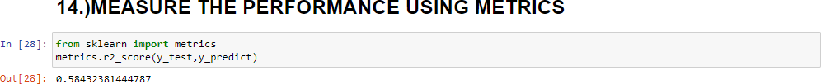**13.) TEST THE MODEL**

**14.) MEASURE THE PERFORMANCE USING METRICS**